Part A:

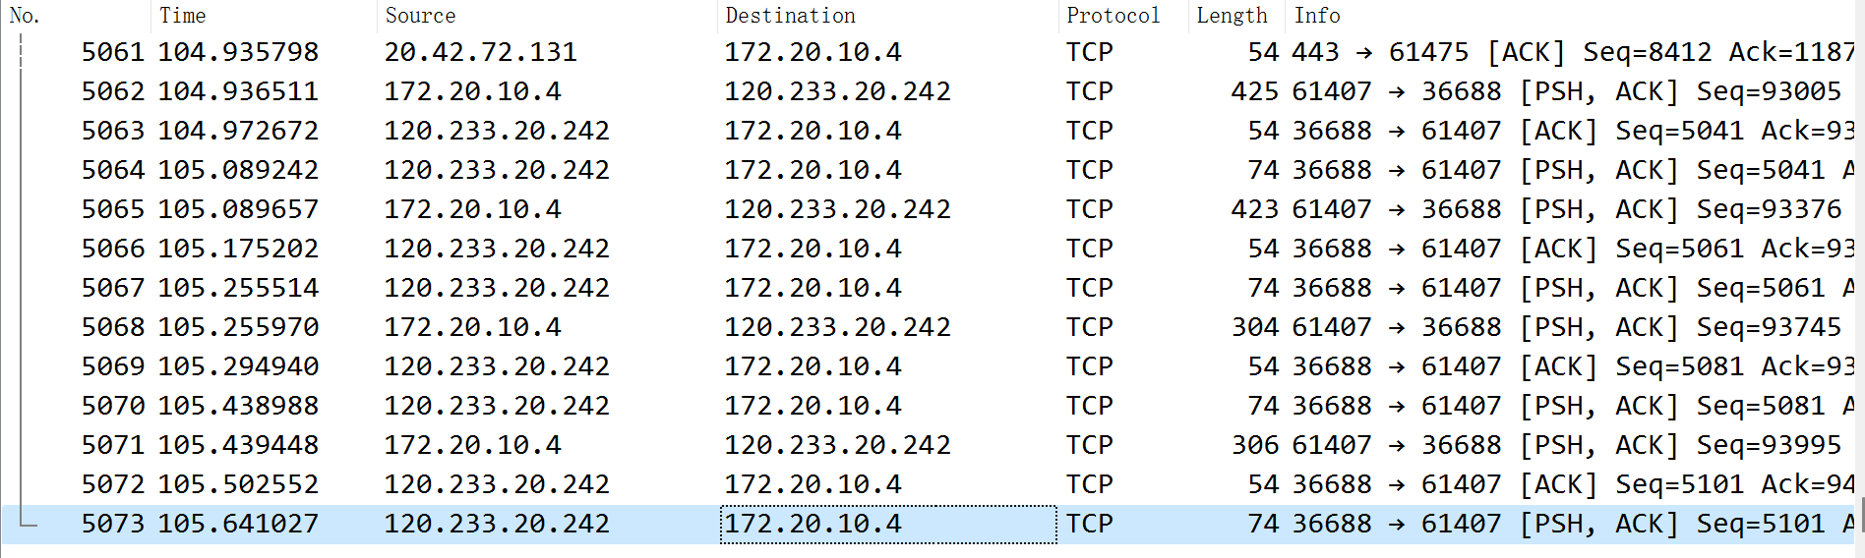

server IP address: 120.233.20.242

layer protocol: TCP

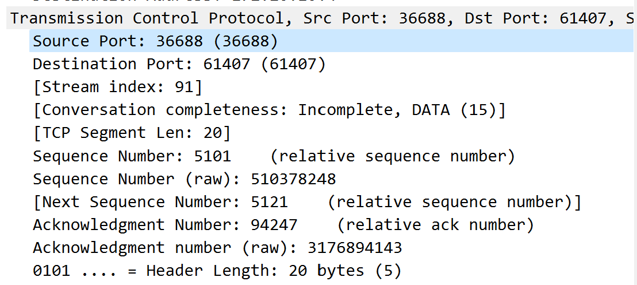

client port: 36688

server port: 61407

stream index: 91

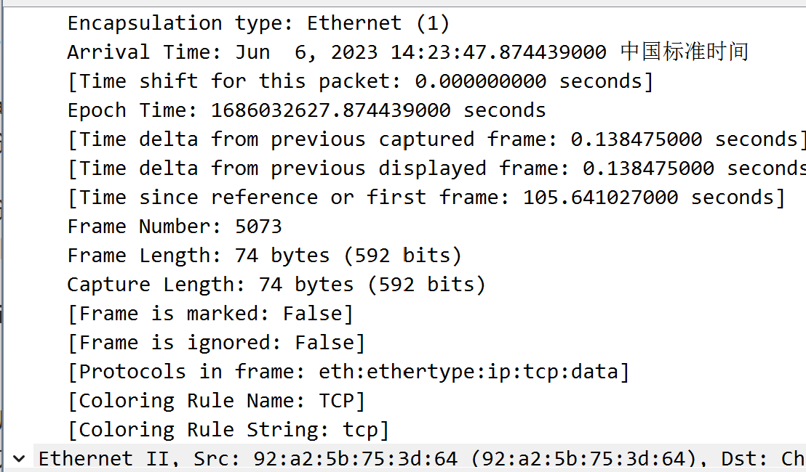

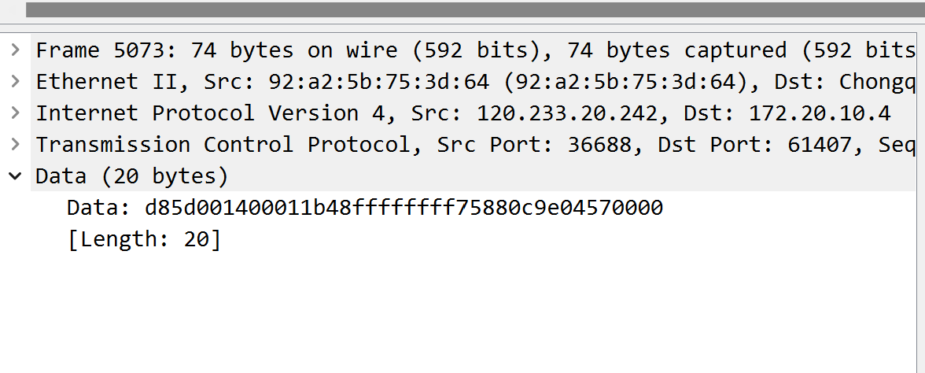

bytes of data have been downloaded: 20 bytes

the size of the downloaded file: 74 bytes

differences:

Bytes of data indicates the total number of bytes of packets captured by Wireshark during network capture. It represents the sum of the sizes of all packets captured.

File size indicates the actual file size when packets captured by the Wireshark are saved as files. When you choose to save captured packets as a file, Wireshark writes the contents of all packets to the file. The file size depends on the number and content of packets captured, as well as the format in which the file is saved.

Part B: 5G and our lives

# Introduction

The Internet of Things represents the future of modern society. It is often used as a term to refer to things that communicate with one another, such as Internet-connected devices and sensors that communicate with one another via different protocols at each layer of the iot layer. In 2020, it is estimated that 50 billion devices will be connected to the Internet, which is an enormous number of devices. (Nordrum, A 2018)

Internet of Things and its definition is becoming more clear than it used to be. Things that we might have imagined a few years ago, like smart homes, digital assistants, smart cars or self-driving cars, trucks, and so on, are now coming to the fore in our lives. "5G" also gradually enters our life. The term "5G" is used to refer to the fifth generation of telecommunications, before it came to be 4G, 3G, 2G, 1G, all of which are still in use today for different applications. Such as 1G voice calls, 2G tautisms and voice navigation, 3G video conferencing, and mobile TV with GPS, all of which are still in use to this day. 4G brings high-speed applications for mobile TV and wearables (Z,S 2015).5G has brought three novel aspects of higher speed, lower latency, and the connection of multiple devices both as Internet of Things sensors and devices.( Pisarov, J & Mester, G 2020).

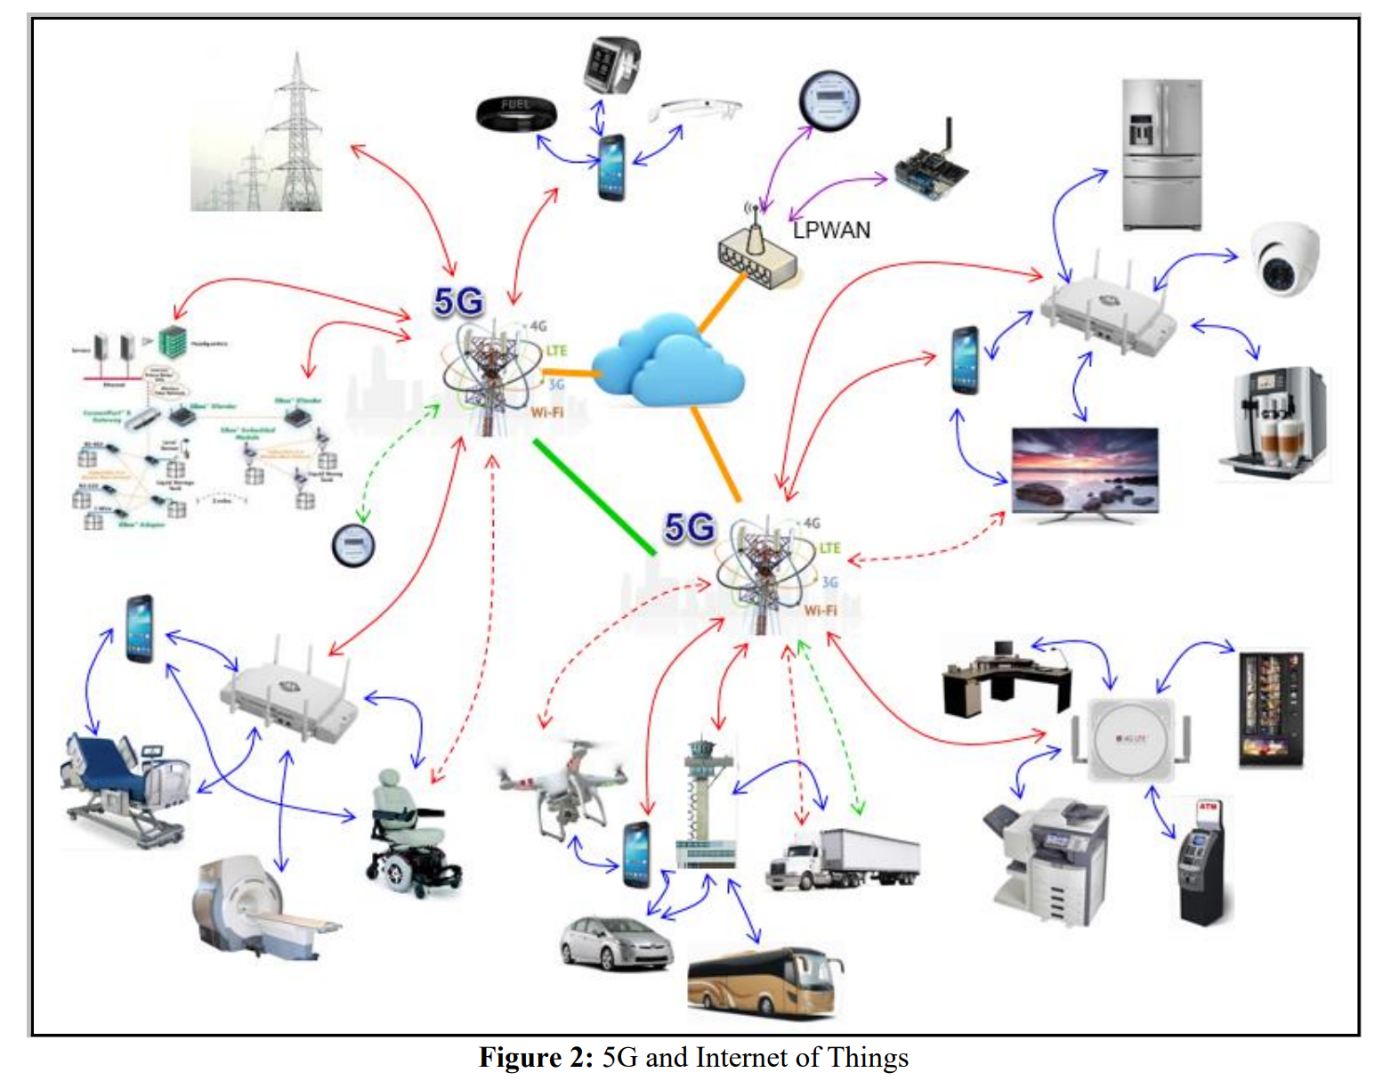

Figure 1 5G and Internet of Things from [3]

The development from the 1st to the 5th generation is from 1G to 5G. Sixteen billion users use cellular connections from 1G to 4G, and this number will continue to grow, with total connections increasing by 100% after 5G, to approximately 29 billion (Ericsson & Sweden 2017). I have included a figure 1 below that clearly shows us the subscriber growth resulting from network evolution such as 1G to 2G and 3G. The popularity of smartphones required faster data and networks with low latency, so 4G and 4G LTE introduced large numbers of users. Devices and users usage will increase this number to 29 billion by 2022 (Ericsson & Sweden 2017). As a result, the benefits provided by 5G are accepted by most people.

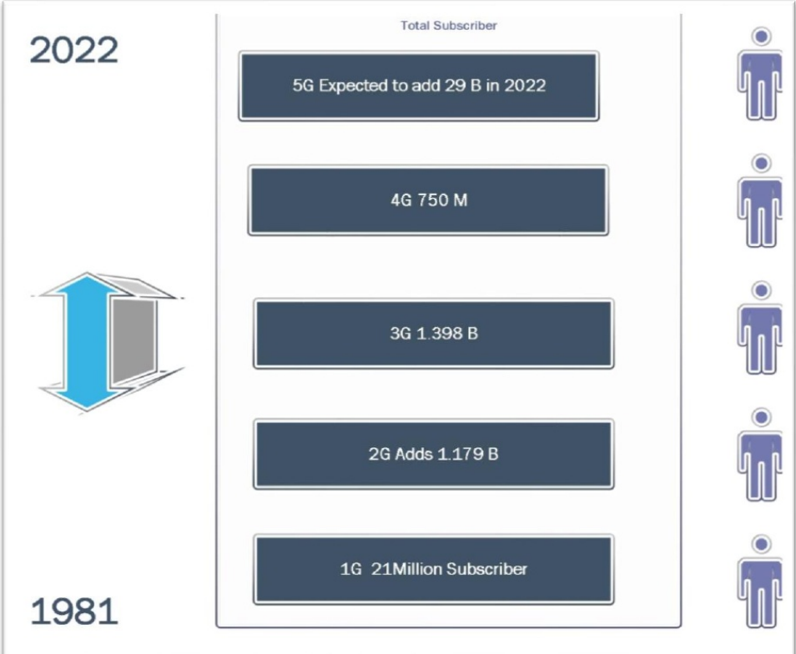

figure 2

Demand is increasing daily, and to meet this increasing demand we need faster networks that can utilize higher data at higher rates. By using these ecosystems, 5G digitization at the individual and societal level will transform from healthcare, agriculture, automotive (Dahlman, E & lD, J 2016).

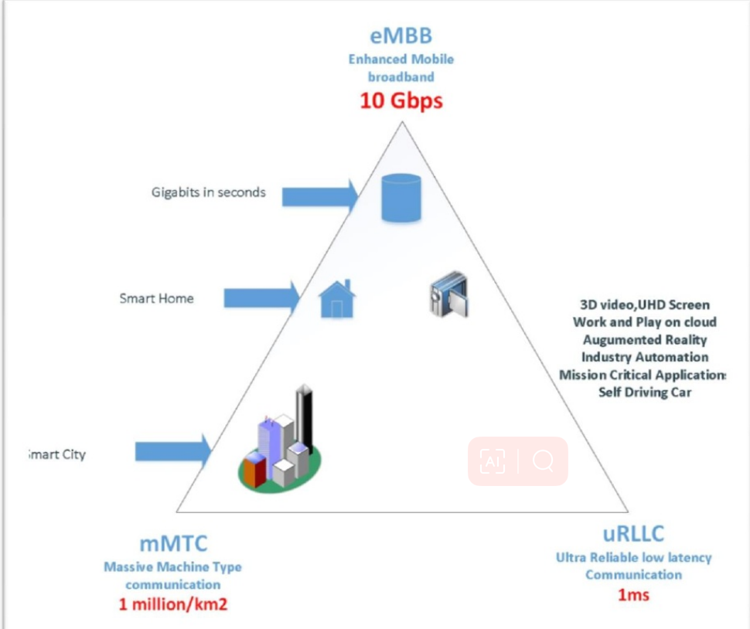

IMT scenarios for 2020 and beyond from the ITU [5]

# 5G and healthcare

In China, there are still problems in the medical field such as imbalanced regional distribution of high quality medical resources and lack of medical talent. With a substantial majority of patients willing to opt for third-class A or specialist hospitals in the larger cities, leading to overcrowding in the largest hospitals and relatively empty hospitals in small and medium-sized towns. In applying 5G networking and technology in smart medicine and medical health, as new endeavors such as remote high definition video consultation, remote surgery, emergency rescue, AI assisted diagnosis and remote medical education become possible.

The COVID-19 in early 2020 has also played a key role in promoting the implementation and popularisation of 5G, and 5G in combination with 4K/8K, AR/VR, as well as other technologies to assist local medical institutions in fighting the pandemic.

# 5G and agriculture

China is a large agricultural country with a large rural area, more than half of which are farmers. Historically, the state has placed the work of "agriculture, rural areas and farmers" in a prominent position. The introduction of 5G has brought about disruptive changes in information technology that will facilitate rapid agricultural and rural development. The "Digital Agriculture Rural Development Plan (2019-2025), published by the Ministry of Agriculture and Rural Affairs, calls for active research on the application of 5G technology in the agricultural and rural areas and the establishment of a sound 5G agricultural intelligent technology system. (Zi Lin 2020)

Using sensors to collect data from every step of crop production, upload it to servers or the cloud via 5G networks, analyze and process the collected data using big data, and provide an "accurate" formula and "smart" management decisions for agricultural material production (Zhao Qing et al. 2022) to boost yields and farmers' incomes. Using 5G technology, data collection and transmission time are shortened and data collection space is expanded. As well as changing the consumer market for agricultural products, 5G has also changed the way consumers shop, not only improving the quality of agricultural products, but also providing a better shopping experience for consumers.

# 5G and automotive

Using 5G to uniformly process vehicular networking information and then issuing scheduling instructions for each vehicle. Rationally planning routes, maximizing road capacity, and proactively avoiding congestion are among the most fundamental applications, and when the road is filled with autonomous vehicles, the ability to dispatch rationally will be magnified. In addition, vehicles driving on the road, each other obstacles, in order to avoid accidents, it is necessary to avoid each other. (Liu Chao et al. 2019) Cycling intelligence has a blind spot and may be unable to recognize certain sudden intruders. When connected to the car, this is equivalent to the amplification of the bicycle intelligence identification circle. For example: A car driving between two trucks, because of the enormous size of the truck, A car cannot easily see the front and back of the next lane, at this time, if the car network works, A car can clearly know whether the next lane is safe, at this time can overtake. Autonomous driving is thus based on the concept of person-oriented driving, which both saves human time and ensures safety.

# Conclusion

The changes that 5G will bring are huge, it could completely change our lives, it will change our healthcare, it will change our agriculture, it will change our transport. As a result, the iot and 5G of the future will be even more revolutionary, with huge digital opportunities for work and life for businesses, businesses and individuals across all walks of life.

# References

C. Kent, 2016, *4G LTE/Advanced Pro and The Road to 5G’ , In 4G LTE/Advanced Pro and The Road to 5G 3rd Edition*, Dahlman, E. & ld, jsps, Amsterdam, Boston, Heidelberg, Paris.

Ericsson. (2017). "Ericsson Mobility Report 2017." Heuveldop, Niklas, Sweden.

Liu Chao, Sun Chao, Ye Qing, & Zhang Yongjie 2019, ‘Application exploration of 5G in intelligent transportation’, *Quality Transportation and Collaborative Governance -- Proceedings of the 2019 Annual Conference on Urban Transportation Planning in China*, vol.3, no,7, pp.3296-3304.

Nordrum, A, 2018, "IEEE Spectrum.", <https://spectrum.ieee.org/tech-talk/telecom/internet/popular-internet-of-things-forecast-of-50-billion-devices-by-2020-is-outdated>

Pisarov, J & Mester, G 2020, ‘The impact of 5G technology on life in 21st century’, *IPSI BgD Transactions on Advanced Research (TAR)*, vol.16, no.2, pp.11-14.

Z, Series Innovations, 2015, "Generations in Telecommunication (1G, 2G, 3G, 4G) ", <http://www.zseries.in/telecom%20lab/telecom%20generations/.>

Zi Lin 2020, ‘Vigorously building Digital Agriculture Countryside to Promote the Digital transformation of China's agriculture -- Head of the Ministry of Agriculture and Rural Affairs interprets the Digital Agriculture Rural Development Plan (2019-2025)’, *Chinese Food*, vol.3, no.3, pp.33-35.

Zhao Qing, LI Guo qiang, Hu Feng 2022, ‘Construction and application of integrated service platform for crop intelligent production in field’, *Journal of Agricultural Big Data*, vol.3, no.4, pp. 29-39.